NAME: VENKATRAMAMOORTHY.G
- Create an object with name, age, and method sayHello().
CODE:
let obj={name:'alice',age:21,sayHello:function(){return "hello world"}};
console.log(obj);
OUTPUT:
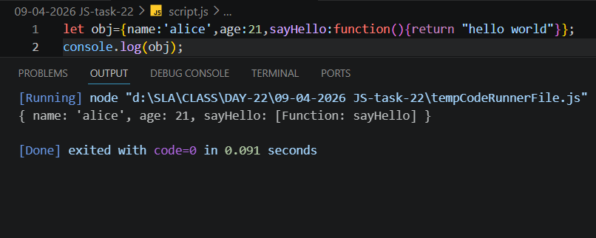
- Access and modify object properties.
CODE:
let obj={name:'alice',age:21,sayHello:function(){return "hello world"}};
console.log(obj);
console.log(obj.name);
console.log(obj.age);
obj.age=22;
console.log(obj.age);
OUTPUT:
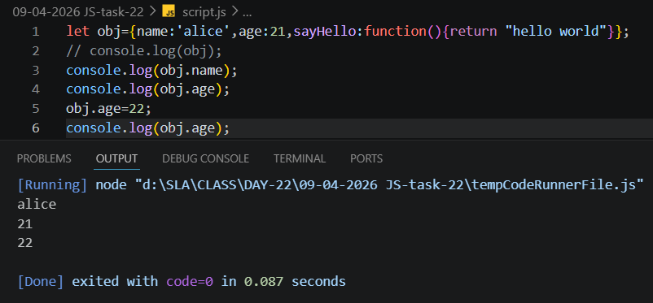
- Call an object method.
CODE:
let obj={name:'alice',age:21,sayHello:function(){return "hello world"}};
console.log(obj.sayHello());
OUTPUT:
